CODE:
#include <iostream>
#include <cstdlib>
#include <ctime>
using namespace std;

long long orignal(){
int arr[5][5];
long long product1 = 1;

cout << "Enter The Numbers of Player1 :" <<endl;
for(int i = 0; i < 5; i++){
for(int j = 0; j < 5; j++){
cin >> arr[i][j];
}
}

cout << "Matrix of Player1 :" <<endl;
for(int i = 0; i < 5; i++){
for(int j = 0; j < 5; j++){
cout << arr[i][j] << " ";
}
cout <<endl;
}

int *p = &arr[0][0];
for(int i = 0; i < 25; i++){
product1 = product1 * (*(p + i));
}

return product1;
}

long long random(){
int array[5][5];
long long product2 = 1;

cout<<"The Random Numbers of Player2 :" <<endl;
for(int i = 0; i < 5; i++){
for(int j = 0; j < 5; j++){
array[i][j] = (rand() % 9) + 1;
cout << array[i][j] << " ";
}
cout<<endl;
}

int *p1 = &array[0][0];
for(int i = 0; i < 25; i++){
product2 = product2 * (*(p1 + i));
}

return product2;
}

void winner(){
long long p1 =orignal();
long long p2 =random();

cout<<"Total Score of Player1: " <<p1<<endl;
cout<<"Total Score of Player2: " <<p2<<endl;

if(p1 > p2){
cout<<"The Winner is Player1" <<endl;
}
else if(p1 < p2){
cout<<"The Winner is Player2" <<endl;
}
else{
cout<<"The Match is Draw" <<endl;
}
}

int main(){
srand(time(0));
winner();
return 0;
}

💡Description: The game calculates and compares the strength of two 5×5 arenas:
- Player 1 represents the original state of the arena, with power values entered by the user.
- Player 2 represents a randomly generated attack, simulating unpredictable forces acting on the arena.
- The product of all numbers in each arena determines the overall strength, and the higher product decides the winner.

2. Technical Objective: Mastery of Memory
The goal is to move beyond simple array indexing (array[i][j]) and master pointer arithmetic:
- Navigate a 2D matrix using memory addresses.
- Pass memory locations to functions for efficient manipulation of data.
- Understand how a 2D matrix is stored linearly in computer memory.

3. Logic & Operation Objective
The game demonstrates your ability to perform key matrix operations:
- Product Calculation: Iterating through every cell of a 5×5 matrix using pointers to calculate a total score.
- Comparison of Scores: Determine which player’s matrix yields a higher product and declare the winner or draw.

Concepts

1. 2D Arrays in Memory
- In C++, a 2D array is stored in Row-Major Order. The computer stores it as one long continuous line of data in memory.
- Original: matrix[row][col]
- In Memory: All elements of Row 0, followed by all elements of Row 1, and so on.
2. Pointer Arithmetic (The Core Constraint)
int *p = &arr[0][0];
- Pointer p is used to store the address of the first element of the 2D array.
- The &arr gets the memory address of that first element.
- Purpose: So we can access all elements of the array in a single loop instead of using nested loops.
*(p + i)
- This dereferences the pointer at position i.
- Purpose: To get the value of each element in the array using pointer arithmetic.

3. Random Number Generation:
- Player2’s matrix is filled with random numbers between 1 and 9.
- rand() % 9 + 1 → generates numbers from 1 to 9.
- srand(time(0)) → seeds the random number generator so numbers are different each run.

4. Product Calculation:
- We calculate the product of all numbers in the matrix for each player.
- The player with the higher product is the winner.

  - Winner Determination:
- Compare the two products:
- If Player1 > Player2 → Player1 wins
- If Player2 > Player1 → Player2 wins
- If equal → Match is a draw

Chunks

- Matrix Creation & Input for player 1:

- A matrix is a 2D array with rows and columns. In this program, we use a 5x5 matrix to store numbers for Player1.
- The matrix is created using the statement:
int arr[5][5];
- The first [5] represents the number of rows, and the second [5] represents the number of columns.

- Matrix Display for player 1:
- To fill the matrix, we use nested loops and take input from the user:
for(int i = 0; i < 5; i++){
for(int j = 0; j < 5; j++){
cin >> arr[i][j];
}
}
Outer loop i → goes through rows
Inner loop j → goes through columns
cin >> arr[i][j]; → takes input for each element in the matrix

- After this step, the 5x5 matrix is ready with all numbers entered by the user.
- The matrix can then be printed or used for calculations.

- Product Calculation (Using Pointer Method):
- The program calculates the product of all elements in the matrix.
- Instead of using nested loops, we can use a pointer to access the matrix as a single line of elements in memory.
int *p = &arr[0][0];
for(int i = 0; i < 25; i++){
product1 *= (*(p + i));
}
Explanation:
- &arr[0][0] → gives the address of the first element of the matrix.
- int *p → pointer to store this address.
- *(p + i) → accesses the i-th element in the flattened 2D array.
- Loop runs 25 times (5 rows × 5 columns) to multiply all numbers.
- product1 stores the total product of all elements.

Code:
#include<iostream>
using namespace std;
long long orignal() {
int arr[5][5];
long long product1 = 1;
cout<<"Enter The Numbers of Player1 :"<<endl;
for(int i = 0; i < 5; i++){
for(int j = 0; j < 5; j++){
cin>>arr[i][j];
}
}
cout<<"Matrix of Player1 :"<<endl;
for(int i = 0; i < 5; i++){
for(int j = 0; j < 5; j++){
cout<<arr[i][j]<< " ";
}
cout<<endl;
}
int *p = &arr[0][0];
for(int i = 0; i < 25; i++){
product1 *= (*(p + i));
}
return product1;
}
int main() {
long long product = orignal();
cout << "Product of Player1's matrix: "<<product<<endl;
return 0;
}

OUTPUT:01
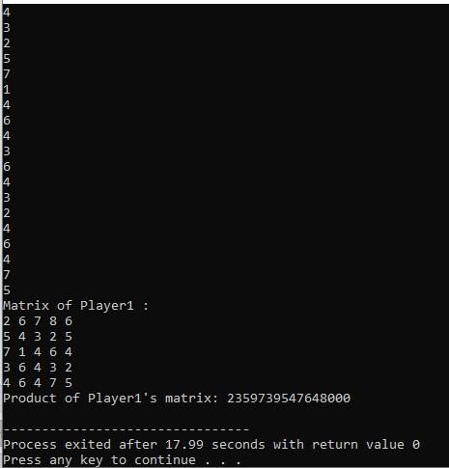

OUTPUT:02
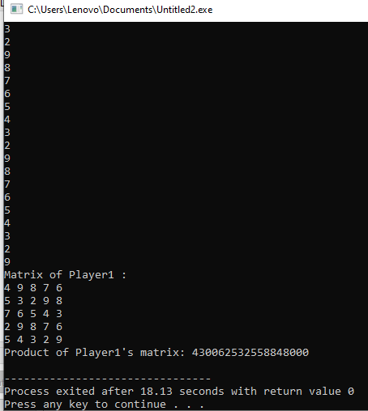

- Matrix Creation & Input for player 2:
int array[5][5];
- Creates a 5x5 matrix for Player2.

- Random Number Generation for player 2:
array[i][j] = (rand() % 9) + 1;
- rand() % 9 → generates numbers from 0 to 8.
- Adding 1 → shifts range to 1 to 9.

- Matrix Display for player 2:
cout << array[i][j] << " ";
- Prints each number as it is generated.

- Pointer Product Calculation:
int *p1 = &array[0][0];
for(int i = 0; i < 25; i++){
product2 *= (*(p1 + i));
}
- p1 points to the first element of the matrix.
- *(p1 + i) accesses each element in memory sequentially.
- Loops through all 25 elements to calculate the total product.

Code:
#include <iostream>
#include <cstdlib>
#include <ctime>
using namespace std;
long long random() {
int array[5][5];
long long product2 = 1;

cout<<"The Random Numbers of Player2 :"<<endl;
for(int i = 0; i < 5; i++){
for(int j = 0; j < 5; j++){
array[i][j] = (rand() % 9) + 1;
cout << array[i][j] << " ";
}
cout<<endl;
}

int *p1 = &array[0][0];
for(int i = 0; i < 25; i++){
product2 *= (*(p1 + i));
}

return product2;
}
int main() {
srand(time(0));
long long product = random();
cout<<"Product of Player2's matrix: "<<product<<endl;
return 0;
}

OUTPUT:01
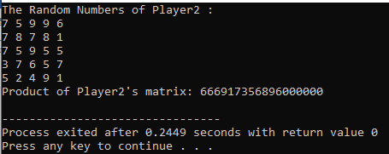

OUTPUT:02
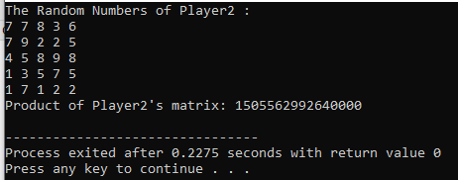

Chunk 3: Winner Determination (if-else Statement)
Explanation
- Calling Functions:
- long long p1 = orignal(); → Calls the Player1 function and stores the product in p1.
- long long p2 = random(); → Calls the Player2 function and stores the product in p2.

- Printing Scores:
- cout << "Total Score of Player1: " << p1 << endl;
- cout << "Total Score of Player2: " << p2 << endl;
Shows the products (scores) of both players.

- Comparing Scores:
if(p1 > p2) {
cout << "The Winner is Player1" << endl;
}
else if(p1 < p2) {
cout << "The Winner is Player2" << endl;
}
else {
cout << "The Match is Draw" << endl;
}
- if(p1 > p2) → Player1 wins if their product is greater.
- else if(p1 < p2) → Player2 wins if their product is greater.
- else → If both products are equal, the match is a draw.

OUTPUT:01
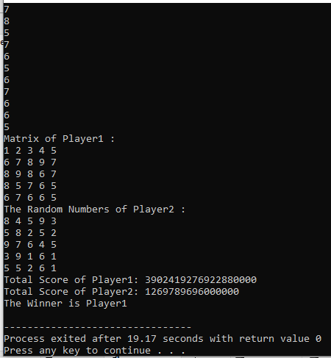

OUTPUT:02
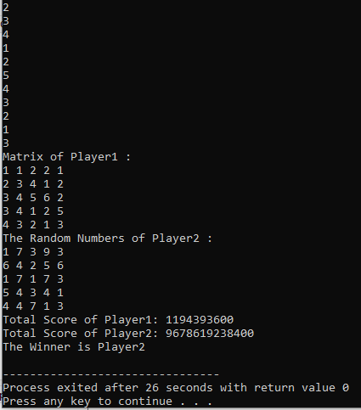

Code

conclusion

- The project created a simple game using two 5×5 matrices for Player1 and Player2.
- Player1’s matrix was entered manually by the user (original matrix).
- Player2’s matrix was generated randomly using the rand() function.
- Both matrices were displayed on the screen using nested loops.
- Pointers were used to access all elements of the matrices and calculate the product of all numbers.
- Using pointers allowed us to treat the 2D arrays as a single block of memory, making multiplication easier.
- The products of both matrices were compared to decide the winner.
- If both products were equal, the game was considered a draw.
- The project demonstrated important C++ concepts:
2D arrays / matrices
- Nested loops for input and display
- Pointers for memory traversal
- Random number generation using rand()
- Conditional statements for decision making

